|  |  |  |  |  |
| --- | --- | --- | --- | --- |
|  |  | | |  |
|  |  | | |  |
|  | TAI Mini-APPs | | |  |
|  | (MyFeatureId) | | |  |
|  |  | | |  |
|  |  | | |  |
| Document Type | **Feature Document (FD)** | | |  |
| Template Version | **6.0b** | | |  |
| Document ID | **document1** | | |  |
| Document Location |  | | |  |
| Document Owner | **Haifeng Yan (HYAN24)** | | |  |
| Document Revision | **A** | | |  |
| Document Status | **Draft** | | |  |
| Date Issued | **2022-06-07** | | |  |
| Date Revised | **yyyy-mm-dd** | | |  |
| Document Classification | GIS1 Item Number: | **27.60/35** | |  |
| GIS2 Classification: | **Confidential** | |
|  | | | | |
|  | | | | |
| Document Approval | | | | |
| Person | Role | | Email Confirmation | Date |
|  |  | |  |  |
|  |  | |  |  |

Printed Copies Are Uncontrolled

# Disclaimer

**This document contains Ford Motor Company Confidential information. Disclosure of the information contained in any portion of this document is not permitted without the expressed, written consent of a duly authorized representative of Ford Motor Company, Dearborn, Michigan, U.S.A.**

**Copyright, Ó 2016 Ford Motor Company**

This document contains information developed and accumulated by and for FORD MOTOR COMPANY. As such, it is a proprietary document, which, if disseminated to unauthorized persons, would provide others with restricted information, data, or procedures not otherwise available, exposing the FORD MOTOR COMPANY to potential harm.

Employees and suppliers having custody of this specification or authorized to use it must be cognizant of its proprietary nature and ensure that the information herein is not made available to unauthorized persons.

FORD MOTOR COMPANY reserves the right to protect this work as an unpublished copyrighted work in the event of an inadvertent or deliberate unauthorized publication. FORD MOTOR COMPANY also reserves its rights under copyright laws to protect this work as a published work.

This document or portions thereof shall not be distributed outside FORD MOTOR COMPANY without prior written consent. Refer all questions concerning disclosure to the author(s) or to any duly authorized representative of Ford Motor Company.

# Contents

Disclaimer 2

Contents 3

1 Introduction 5

1.1 Document Purpose 5

1.2 Document Scope 5

1.3 Document Audience 5

1.3.1 Stakeholder List 5

1.4 Document Organization 5

1.4.1 Document Context 5

1.4.2 Document Structure 6

1.5 Document Conventions 6

1.5.1 Requirements Templates 6

1.6 References 7

1.6.1 Ford Documents 7

1.6.2 External Documents and Publications 7

1.7 Glossary 7

1.7.1 Definitions 7

1.7.2 Abbreviations 7

1.7.3 Parameters / Values 8

2 Feature Overview 9

2.1 Purpose and Description of Feature 9

2.2 Feature Variants 10

2.2.1 Regions & Markets 10

2.3 Input Requirements 10

2.3.1 Legal Requirements 10

2.3.2 Trustmark Requirements 10

2.3.3 Industry Standards 10

2.4 Lessons Learned 10

2.5 Assumptions 11

3 Feature Context 12

3.1 Feature Context Diagram 12

3.2 List of Influences 12

4 Feature Modeling 14

4.1 Operation Modes and States 14

4.2 Use Cases 14

4.2.1 Use Case Diagram 14

4.2.2 Actors 15

4.2.3 Use Case Descriptions 16

4.3 Driving and Operation Scenarios 31

4.4 Decision Tables 32

5 Feature Requirements 33

5.1 Functional Requirements 33

5.1.1 Error Handling 33

5.2 Non-Functional Requirements 33

5.2.1 Safety 33

5.2.2 Security 33

5.2.3 Reliability 33

5.3 HMI Requirements 33

5.4 Other Requirements 33

5.4.1 Design Requirements 33

5.4.2 Manufacturing Requirements 35

5.4.3 Service Requirements 35

5.4.4 After Sales Requirements 36

5.4.5 Process requirements 36

6 Functional Safety 37

6.1 System Behaviors for HARA 37

6.2 Safety Assumptions 37

6.3 Safety Goals 37

6.4 Functional Safety Requirements 38

6.4.1 <Goal 1 Name> 38

6.4.2 <Goal 2 Name> 38

6.4.3 Derivation of Requirements on Assumptions 38

6.5 (Decomposed) Functional Safety Requirements 38

7 Architecture 40

7.1 Functional Architecture 40

7.1.1 List of Functions 40

7.2 Logical Architecture 41

7.2.1 Logical Elements 41

7.2.2 Logical Interfaces 42

8 Open Concerns 43

9 Revision History 44

10 Appendix 45

**List of Figures**

Figure 1: Sample Context Diagram 11

Figure 2: Feature Operation Modes and States 13

Figure 3: Use Case Diagram 14

Figure 4: Functional Boundary Diagram 21

Figure 5: Logical Boundary Diagram 22

**List of Tables**

Table 1: Features described in this FD 5

Table 4: Ford internal Documents 7

Table 5: External documents and publications 7

Table 6: Definitions used in this document 7

Table 7: Abbreviations 7

Table 8: Parameters / Values used in this document 8

Table 2: Feature Variants 9

Table 3: Regions & Markets 9

Table 9: List of Influences 12

Table 10: Operation Modes and States 13

Table 11: Transitions between Operational Modes and States 14

Table 12: List of Actors 15

Table 13: Sample Decision Table 15

Table 14: System Behaviors for HARA 18

Table 15: Functional Safety Assumptions 18

Table 16: Functional Safety Goals 19

Table 17: Requirements Decomposition Table 20

Table 18: List of Functions 22

Table 19: Logical Elements 23

Table 20: Logical Interfaces 23

Table 21: Open Concerns 24

# Introduction

## Document Purpose

A Feature Document (FD) document specifies **what** the feature shall do and how it shall behave from customer perspective. It should also provide reasoning and background **why** we have the feature in the vehicle.

The FD also serves as an Item Definition as defined by ISO26262 for those features, which follow the Ford Functional Safety process.

To get more information about the concept of feature, function and component level abstraction refer to the [Ford RE Wiki](http://wiki.ford.com/display/RequirementsEngineering/Requirements+Engineering+for+SW+Enabled+Features). For details on the Ford Functional Safety (ISO26262) process refer to the [Ford Functional Safety Sharepoint](https://pd3.spt.ford.com/sites/GlobalFunctionalSafety/Pages/default.aspx).

## Document Scope

This Feature Document (FD) specifies the following features:

|  |  |  |  |
| --- | --- | --- | --- |
| **Feature ID** | **Feature Name** | **Owner** | **Reference** |
| <Add VSEM Global Feature Dictionary ID> | TAI Mini-APPs | Haifeng Yan<HYAN24> | <Add VSEM Link> |
|  |  |  |  |

Table 1: Features described in this FD

## Document Audience

The FD is written by the feature owner of <Haifeng Yan>. All Stakeholders, i.e., all people who have a valid interest in the feature should read and, if possible, review the FD. It needs to be guaranteed, that all stakeholders have access to the currently valid version of the FD.

**#Hint:** The FD template has the IP Classification “Proprietary” by default. IP Classification “Confidential” might be required in some cases, e.g. by Ford Functional Safety.

**#Macro:** [Add Ins -> Edit Document Properties macro](http://wiki.ford.com/display/RequirementsEngineering/How+to+use+the+Specification+Templates#HowtousetheSpecificationTemplates-EditDocProperties) (select “Proprietary” for “Document Classification”)

### Stakeholder List

For the latest list of stakeholder of the feature and their influence refer to <Put VSEM Link here>.

|  |  |  |  |
| --- | --- | --- | --- |
| **Name** | **CDSID** | **Role** | **Stakeholder Group** |
| Haifeng Yan | HYAN24 | Tech Lead |  |
| Yu Wang | YWANG536 | Product Owner |  |
|  |  |  |  |
|  |  |  |  |

**#Hint:** Refer to [Ford RE Wiki – Stakeholder List](http://wiki.ford.com/display/RequirementsEngineering/Stakeholder+Analysis) on how to create a stakeholder list. The stakeholder list should be stored in VSEM in the pseudo folder “General Data Artifacts” of the corresponding feature.

## Document Organization

### Document Context

Refer to the [Specification Structure page](http://wiki.ford.com/display/RequirementsEngineering/Specification+templates) in the [Ford RE Wiki](http://wiki.ford.com/display/RequirementsEngineering/Requirements+Engineering+for+SW+Enabled+Features) to understand how the FD relates to other Ford Requirements Documents and Specifications.

### Document Structure

The structure of this document is explained below:

**Section 1** – Introduction how to use this document including responsibilities and requisite documents. Explains the terminology. Gives a clarification of the definitions, concepts and abbreviations used in the document.

**Section 2** – Feature Description. States briefly the background and the purpose of the feature, feature variants and corresponding regions and markets. Also includes input requirements, assumptions and constraints.

**Section 3** – Feature Context describes all external entities, which have an influence on the feature.

**Section 4** – Feature Modeling. Contains Use Case, Driving Scenarios, State Charts to describe the functional behavior of the feature.

**Section 5** – Safety. Lists System Behaviors and Safety Goals of the feature.

**Section 6** – Feature Requirements. Lists functional and non-functional requirements of the feature.

**Section 7** – Architecture. Shows the coarse architecture, which the feature requirements are deployed to. Describes the elements and the boundary of the feature as well as the decomposition and distribution of associated functions.

**Section 8** – List of Open Concerns

**Section 9** – Document Change History including a list of new or modified requirements. The requirements in this document are tagged, and this section contains different types of tables listing all, new, or changed requirements by their title and page no.

**Section 10** – Appendix

**#Hint:** All sections are mandatory, unless explicitly marked by the tag “#Classification” as “optional” or as applicable e.g. to certain domains like “Functional Safety”.

## Document Conventions

### Requirements Templates

Each requirement, use case or scenario in this specification shall follow the corresponding template given in the document template *Specification_Macros.dotm* at [RE Wiki - Specification Templates](http://wiki.ford.com/display/RequirementsEngineering/Specification+templates?src=contextnavpagetreemode).

**#Hint:** The Specification_Macros.dotm template also provides macros to insert the requirement templates. Refer to “[How to use the Specification Templates](http://wiki.ford.com/display/RequirementsEngineering/How+to+use+the+Specification+Templates?src=contextnavpagetreemode)” on how to enable the macros and the requirements templates in this specification.

The requirements macro and requirements templates also enable the import of the specification to VSEM (refer to ["How to import specifications into VSEM as separate requirements"](http://wiki.ford.com/pages/viewpage.action?pageId=104991616&src=contextnavpagetreemode)).

#### Identification of requirements

The unique requirement ID given in the headline of any requirement follows the requirement throughout the development process. The requirement ID format follows a well-defined syntax.

All identifiers in a FD shall be composed of 4 parts:

* A leading prefix, which indicates the type of requirement (R=Requirement, UC=Use Case, SC=Scenario, …)
* A prefix, which indicates the abstraction level (F=Feature, FNC=Function, CMP = component).
* Followed by a name, indicating the scope, which the requirement belongs to (e.g. feature or function name )
* Ending with the actual requirement number

*Example:*

*R_F_AutoLamps_00004* This is the fourth requirement on feature level for the feature Autolamps.

#### Requirements Attributes

The templates provided by *Specification_Macros.dotm* define a list of attributes for each requirement. This helps to classify the requirement. The attributes are explained at [RE Wiki - Requirements Attributes](http://wiki.ford.com/display/RequirementsEngineering/Requirements+Attributes?src=contextnavpagetreemode).

## References

### Ford Documents

List here all Ford internal documents, which are directly related to the feature.

| **Reference** | **Title** | **Doc. ID** | **Document Location** | **Revision** |
| --- | --- | --- | --- | --- |
| [aaa] |  |  |  |  |
|  |  |  |  |  |

Table 2: Ford internal Documents

### External Documents and Publications

The list of external documents could include books, reports and online sources.

**#Hint:** You may refer to [IEEE Citation Reference](http://www.ieee.org/documents/ieeecitationref.pdf) on how to format a reference.

| **Reference** | **Document / Publication** | **Document Location** |
| --- | --- | --- |
| [bbb] |  |  |
|  |  |  |

Table 3: External documents and publications

## Glossary

**#Hint**: Terms, concepts and abbreviations used in the document shall be defined and illustrated here. Note that changes to terms and/or concepts described in this section tend to cause major updates to this document.

The tables below have feature specific definitions and abbreviations. For additional, non-feature specific terms please refer to the [RE Glossary](http://wiki.ford.com/display/RequirementsEngineering/Glossary?src=contextnavpagetreemode)

### Definitions

| **Definition** | **Description** |
| --- | --- |
| Mini-APPs | Mini-APPs is a customized version of Tencent's mini-programs. Car owners can use different mini applications in the car to meet their needs, which is equivalent to an application. |
|  |  |
|  |  |
|  |  |
|  |  |
|  |  |
|  |  |

Table 4: Definitions used in this document

### Abbreviations

| **Abbr.** | **Stands for** | **Description** |
| --- | --- | --- |
|  |  |  |
|  |  |  |
|  |  |  |
|  |  |  |
|  |  |  |

Table 5: Abbreviations

### Parameters / Values

| **Name** | **Description** | **Range / Resolution** |
| --- | --- | --- |
|  |  |  |
|  |  |  |
|  |  |  |

Table 6: Parameters / Values used in this document

# Feature Overview

## Purpose and Description of Feature

**#Hint:** Some descriptive text to explain the purpose and functionality of the feature.

小场景为TAI随行应用的子应用，本规范主要描述小场景功能需求及用例。

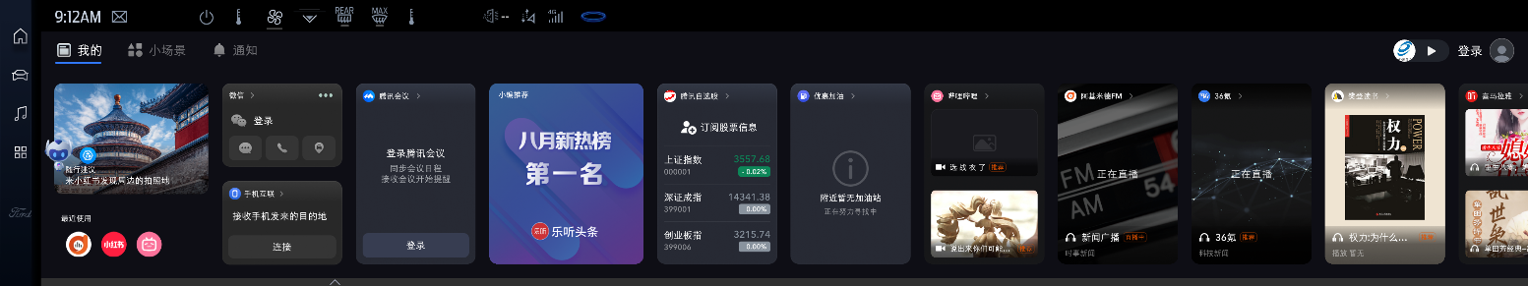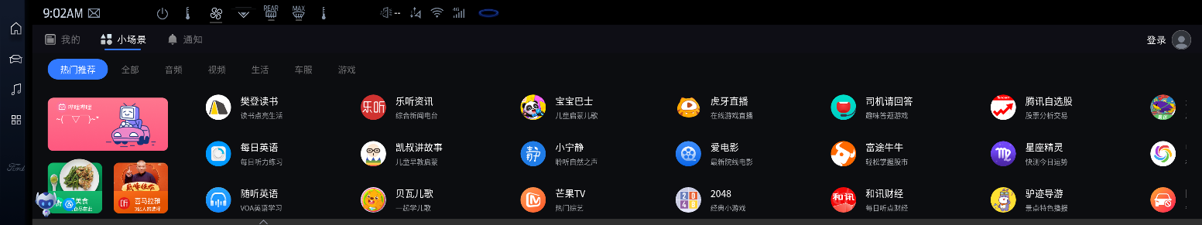小场景集合众多由第三方内容提供商提供的应用服务，用户可在不安装第三方APK的前提下在随行中直接使用对应服务。此外，小场景为移动在线服务提供稳定SOTA。功能样式如下

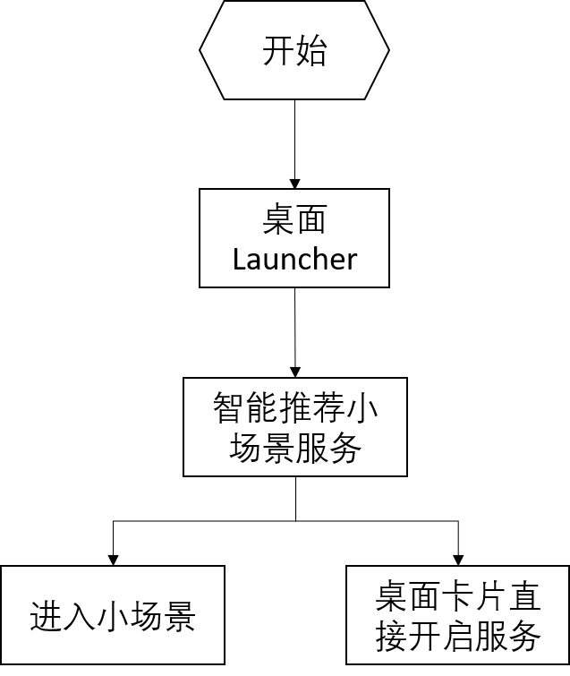**智能推荐小场景：**

**用户自发打开小场景：**

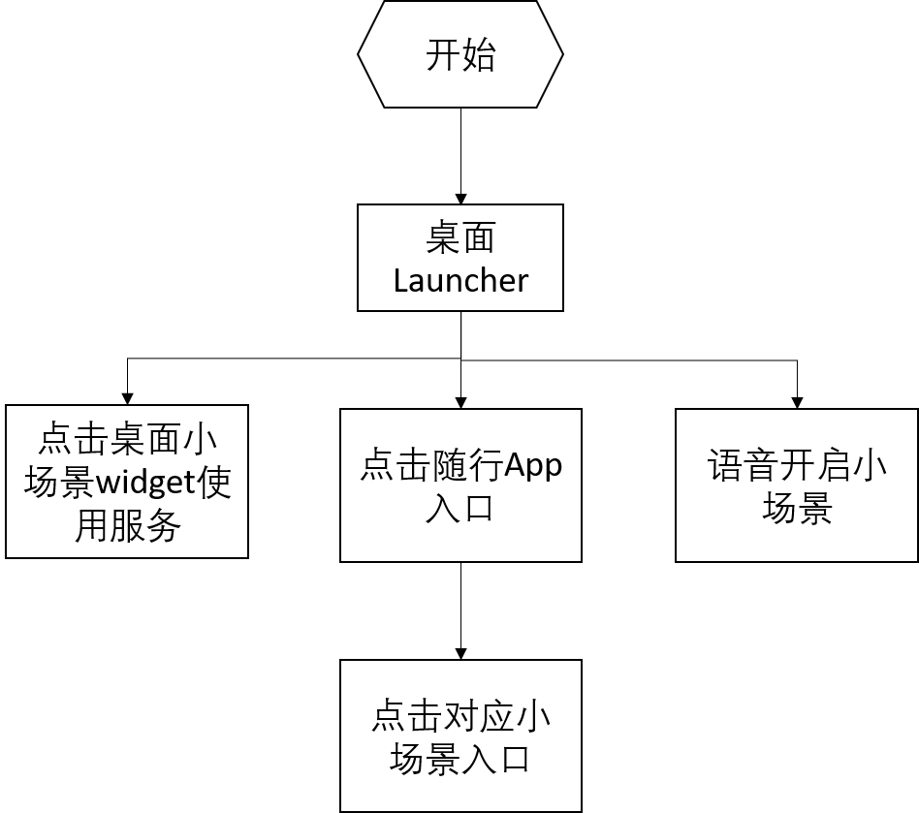

涵盖的小程序详见《小程序功能清单》：

## Feature Variants

**#Hint:** Definitions for different variants of the feature (if applicable). Give each variant a descriptive name by which it can be referenced further on in the document. If no variant exists, state “No Feature Variants”.

The Variant Description should give a short informative text which describes the variants of the feature.

|  |  |  |
| --- | --- | --- |
| Variant Name | Variant Description | Remarks |
|  | No Feature Variants |  |
|  |  |  |
|  |  |  |

Table 7: Feature Variants

### Regions & Markets

**#Hint:** Description of purpose and functionality of the feature. If there is no variant, give feature name in first column.

|  |  |  |  |  |  |  |
| --- | --- | --- | --- | --- | --- | --- |
| **Market /**  **Region**  Variant Name | **North America** | **South America** | **Europe** | **Middle East / Africa** | **Asia / Pacific** | **China** |
| **TAI-MiniAPPs** |  |  |  |  |  | *Y* |

Table 8: Regions & Markets

## Input Requirements

**#Hint:** List all input requirements, which are relevant for the feature. Typically, attribute requirements, legal requirements as well as national and international standards have to be considered.

### Legal Requirements

TBD

1.用户隐私协议；

### Trustmark Requirements

### Industry Standards

## Lessons Learned

**#Hint:** Additional information and lessons learned from previous development or related features. A typical source for Lessons Learned is the FMA Quality History.

**#Functional Safety:** In context of Functional Safety Lessons Learned and similar information will be used to check the completeness of the Functional Safety Goals and assumptions in the Hazard Analysis and Risk Assessment (HARA).

**#Link:** [Ford Functional Safety Sharepoint](https://pd3.spt.ford.com/sites/GlobalFunctionalSafety/Pages/default.aspx)

1. 总线信号丢失；
2. 数据传输过程中突然失去供电；
3. 数据传输过程中网络信号不稳定；

## Assumptions

**#Classification**: Optional

**#Hint:** A list of known assumptions concerning the effects of the feature’s behavior on other features or elements (i.e., dependencies) as well as assumptions on the behavior expected by the feature (e.g. known limitations). During the course of the feature development most of those assumptions are typically either converted into actual requirements or discarded at some point – such that this chapter remains mostly empty. For assumptions, which are relevant for the Functional Safety process refer to chapter 6.2 “Safety Assumptions”

# Feature Context

## Feature Context Diagram

**#Hint:** High level diagram of feature interactions with the environment, people or other feature or other external entities.

**#Link:** [RE Wiki - Context Diagram](http://wiki.ford.com/pages/viewpage.action?pageId=107676234&src=contextnavpagetreemode)

**

Figure 1: Sample Context Diagram

## List of Influences

|  |  |  |
| --- | --- | --- |
| **ID** | **External Entity** | **Influence Description** |
| I1 | Power Supply | 功能需要在有供电的情况下实现 |
| I2 | Vehicle Status | 功能实现需要判断车辆状态，如蓝牙状态、音频通道状态等 |
| I3 | WeChat | 小程序卡片展示依赖于与微信卡片的整体布局 |
| l4 | MAP | 手机微信分享到车端的位置信息可以进行导航 |
| l5 | Cellular signal quality | 信号质量将会影响影响云端服务的下发 |
|  |  |  |
|  |  |  |
|  |  |  |
|  |  |  |
|  |  |  |

Table 9: List of Influences

# Feature Modeling

## Operation Modes and States

**#Classification:** Optional (Mandatory for Functional Safety)

**#Link:** [RE Wiki – State Charts](http://wiki.ford.com/display/RequirementsEngineering/State+Charts?src=contextnavpagetreemode)

**#Hint:** State Charts are a popular means to express feature behavior in terms of states and modes. An advantage of this state machine like approach is that consistency can be easily verified.

Figure 2: Feature Operation Modes and States

|  |  |  |
| --- | --- | --- |
| **State** | **Description** | **Requirements Reference** (optional) |
| S1 | Standby | 随行APP关闭状态 |
| S2 | Working | 小场景在前台时为用户提供音，视频等其他内容服务 |
| S3 | Active | 用户打开随行APP，但未打开某一小场景 |
|  |  |  |
|  |  |  |

Table 10: Operation Modes and States

|  |  |  |
| --- | --- | --- |
| **Transition ID** | **Description** | **Requirements Reference**  (optional) |
| T1 | 用户通过点击或语音助手唤醒小场景服务 |  |
| T2 | 提供展示，播放服务或结束 |  |
| T3 | 用户打开随行主界面 |  |
| T4 | 用户退出随行主界面 |  |
| T5 | 用户点击或语音唤醒某一小场景应用 |  |

Table 11: Transitions between Operational Modes and States

## Use Cases

**#Classification:** Optional

**#Link:** [RE Wiki – Use Cases](http://wiki.ford.com/display/RequirementsEngineering/Use+Cases+Overview?src=contextnavpagetreemodehttp://wiki.ford.com/display/RequirementsEngineering/Use+Cases?src=contextnavpagetreemode)

### Use Case Diagram

**

Figure 3: Use Case Diagram

### Actors

| Actor | Description |
| --- | --- |
|  |  |
|  |  |
|  |  |

Table 12: List of Actors

### Use Case Descriptions

**#Classification:** Optional

**#Macro:** [Add Ins -> Add Requirement macro](http://wiki.ford.com/display/RequirementsEngineering/How+to+use+the+Specification+Templates#HowtousetheSpecificationTemplates-AddNewRequirement) (select “Use Case” as type)

注：Failure behavior的序号对应Expected Behavior中的序号，具体针对对应序号的行为没有按照期望实现时所采取的措施。

Use Case时序后续补充

## Driving and Operation Scenarios

**#Classification:** Optional (Mandatory for Functional Safety)

**#Macro:** [Add Ins -> Add Requirement macro](http://wiki.ford.com/display/RequirementsEngineering/How+to+use+the+Specification+Templates#HowtousetheSpecificationTemplates-AddNewRequirement) (select “Scenario” as type)

**#Functional Safety:** Driving and operating scenarios which impact the functionality of the feature can be used to check, if the situation analysis in the HARA is complete

**#Link:** [RE Wiki – Driving Scenarios](http://wiki.ford.com/display/RequirementsEngineering/Driving+Scenarios?src=contextnavpagetreemode)

## Decision Tables

**#Classification:** Optional

**#Link:** [RE Wiki – Decision Tables](http://wiki.ford.com/display/RequirementsEngineering/Decision+Table).

**#Hint:** Use decision table, if behavior is not state based (in that case prefer state chart from ch. 4.1) and based purely on current inputs.

|  |  |  |  |  |
| --- | --- | --- | --- | --- |
| **Input Signal 1** | **Input Signal 2** | **Input Signal 3** | **Input Signal 4** | **Output Signal** |
| Value I1 | Value I2 |  |  | Value O1 |
|  |  |  |  |  |

Table 13: Sample Decision Table

# Feature Requirements

**#Macro:** [Add Ins -> Add Requirement macro](http://wiki.ford.com/display/RequirementsEngineering/How+to+use+the+Specification+Templates#HowtousetheSpecificationTemplates-AddNewRequirement) (select “Requirement” as type)

**#Functional Safety:** In general, safety requirements are not listed here. However, it is possible that later in the development process, a non-safety requirement becomes a safety requirement. In such a case it may remain on this list.

**#Link:** [RE Wiki – How to write good requirements](http://wiki.ford.com/display/RequirementsEngineering/How+to+write+better+requirements?src=contextnavpagetreemode).

## Functional Requirements

### Error Handling

## Non-Functional Requirements

***#Hint:*** *Non-functional requirements specify some performance criteria in addition to the functional behavior given defined by the functional requirements. Timing (if not already included in the functional requirements), security details (e.g. how secure does an algorithm have to be) reliability (e.g. mean time between failure) or maintainability could be specified in this section.*

### Safety

**#Hint:** Only those safety requirements, which are not related to Functional Safety (ISO26262) should go here. For Functional Safety refer to chapter 6 “Functional Safety”.

### Security

用户个人信息需严格按照信息安全保护法，确保用户个人数据信息在任何传递过程中不泄露；t.b.d

## HMI Requirements

**#Hint:** Requirements in this section could specify details of e.g. the icons, the GUI or the sounds.

## Other Requirements

#### 整体功能描述

1. 当满足某些条件时，sync+可推荐用户使用某个服务，用户可通过手控或语音打开服务, 语音控制小场景。

其中语音控制小场景功能如下：

|  |  |  |  |
| --- | --- | --- | --- |
| 功能领域 | 功能名称 | 功能描述 | 示例语料 |
| 小场景控制 | 打开小场景 | 打开某一个小场景 | 打开喜马拉雅小程序 打开哔哩哔哩小场景 打开凯叔讲故事 |
| 关闭小场景 | 关闭某一个小场景 | 关闭喜马拉雅小程序 关闭哔哩哔哩小场景 关闭凯叔讲故事 |
| 小场景服务 （部分规划中） | 内容搜索 | 语音搜索小场景内的内容 | 用喜马拉雅搜索赘婿 |
| 内容点播 | 语音点播小场景内的内容 | 用喜马拉播放白眉大侠 |
| 订阅内容查看 | 语音查看小场景的订阅内容 | 用喜马拉雅查看我的订阅 |
| 历史记录播放 | 语音播放小场景的历史记录 | 用喜马拉雅播放历史记录 |
| 历史记录查看 | 语音查看小场景的历史记录 | 用喜马拉雅查看最近播放 |
| 推荐内容播放 | 语音播放小场景的推荐内容 | 用喜马拉雅查看今日推荐 |
| 推荐内容查看 | 语音查看小场景的推荐内容 | 用喜马拉雅播放今日推荐 |
| 按类型查看 | 语音查看小场景的特定分类 | 用喜马拉雅播放情感生活类 |
| 找美食多轮对话 | 用多轮对话的方式完成餐厅的订座、排号、打电话给商家、发起导 航等服务 | 我想预订海底捞的座位 |

1. 当用户自发想使用某个服务时，可通过搜索或浏览在随行中找到需要的小场景并打开使用。其中，随行中涉及到的卡片及对应信息包含如下：

|  |  |  |  |  |  |  |
| --- | --- | --- | --- | --- | --- | --- |
| 推荐类型 | 服务 | Lv1分类 | Lv2分类 | 服务能力描述 | 优先级 | 端 |
| 卡 片 式 场景伴随 | 随行推荐 | 运营活动 | 运营卡 | 运营专题活动、运营榜单活动等 | 中 | IVI |
| 生活财经 | 股票 | 腾讯自选股 | 提供实时的股票证券资讯，登陆后可查看用户已关注的股票 | 中 | IVI |
| 电影 | 爱电影 | 正在热映的影片信息 | 高 | IVI |
| 精彩影音 | 音频 | 喜马拉雅 | 推荐音频内容 | 高 | IVI |
| 阿基米德 | 直播电台 | 高 | IVI |
| 樊登读书 | 推荐有声书 | 高 | IVI |
| 视频 | 哔哩哔哩 | 推荐视频内容 | 高 | IVI |
| 发现周边 | 加油 | 优惠加油 | 推荐周边优惠加油站 | 高 | IVI |
| 消 息 式 场景推荐 | 沿途/周边的POI搜索  /推荐 | 能源场景-智慧加油 | 低油提醒 | 识别到车辆低油后，提示用户查找加油站。用户同意后，基于用户导航情况，搜索周边或沿途加油站。需要用腾讯地图，或者其他地图配合提供导航信息、加油站搜  索等接口。 | 高 | IVI |
| 油价上涨提醒 | 在国内油价调整窗口期前，如果预测油价上涨，则提醒用户油价即将上涨。并送给  用户加油优惠券或者引导用户查看附近有优惠的加油站。 | 高 | IVI |
| 加油优惠 | 识别到当前位置附近有加油优惠且该场景适用推加油优惠时，给用户发消息，让用  户点击进到小场景具体的加油优惠页。 | 高 | IVI |
| 天气 | 异常天气提醒 | 提醒用户中国天气网发布的当前位置的异常天气提醒 | 高 | IVI |
| 内容推荐 | 驻车后推送视频 | 用户驻车后若干时间后，为用户推送视频小场景（当前为哔哩哔哩） | 高 | IVI |
| 多端内容服务流转 | 内容续播 | 听服务内容续播 | 支持部分音频服务小场景在车上直接续播用户没有播放完的内容。  支持在特定场景通过随行卡或随行内的通知为用户推送续播的内容，用户选择后直接开始续播。满足用户多端内容续播的需求  音频服务小场景的续播，已接入喜马拉雅，36氪 | 高 | IVI |
| 登录 | / | 登录引导 | 在用户未登录的情况下，通过途迹的服务数据的消息通知，引导用户微信扫码登录 | 高 | IVI |
| 搜索结果推荐 | POI挂接服务 | 加油 | 优惠加油 | 当搜索加油站或查看加油站时，如果该加油站有优惠加油服务，可以在POI信息中  进行显示（需要使用腾讯地图） | 中 | IVI |

1. 用户还可使用各个小场景透出的服务。

界面原型：



（仅供参考，实际交互文件以UE输出为准）

参考文件：

   

#### 硬件依赖

1.系统资源需求；

详见《腾讯随行TAI 3.0系统依赖》章节2.1

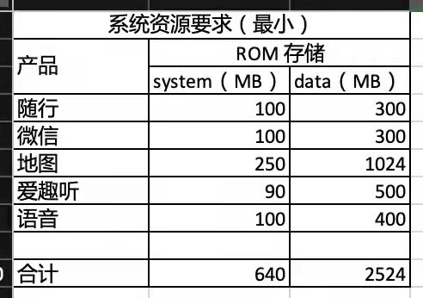

2.惯导要求

详见《腾讯随行TAI 3.0系统依赖》章节2.2.2

### Design Requirements

***#Hint:*** *Requirements of a Logical Function should be typically agnostic of their SW/HW implementation*. If for specific reasons the function owner needs to define explicitly design constraints on the solution, it can be done in this chapter.

#### 小场景账号关联

小场景（MiniAPPs）基于腾讯TAI账号体系，用户在实际使用过程中，通过账号关联实现福特账号和腾讯车联账号在车机上同登同出。

用户当用户在小场景车机应用（完成账号关联后，用户后续登录 SYNC+ 福特账号时，其已关联的 TAI 账号将自动登录。同理，当用户登出福特账号后，其 TAI 账号 将自动登出**。**

账号关联功能列表：

|  |  |  |  |
| --- | --- | --- | --- |
| 一级功能 | 二级功能 | 功能描述 | 优先级 |
| TAI账号关联 | 账号关联 | 福特账号和TAI账号关联 | 高 |
| 账号解除关联 | 福特账号和TAI账号解除关联 | 高 |
| 同登同出 | 福特账号登录、登出，TAI账号随之登录、登出 | 高 |

##### 账号关联，腾讯小程序车机应用内

用户在 SYNC+爱趣听和腾讯小程序应用内登录 TAI 账号后，可以选择是否关联当前已登录的福特账号。

**前置条件**：SYNC+为福特账号已登录状态，爱趣听和腾讯小程序未登录。

**关联数量限制**：同一个福特账号只能关联一个 TAI 账号。反之，同一个 TAI 账号只能关联一 个福特账号，两者为一一映射关系。

**业务规则描述**：

1. 用户扫码登录：用户使用手机微信扫描车机应用登录二维码，手机微信将跳转至“腾讯我的车”小程序，用户点击“微信账号登录”并允许爱趣听 or 车载腾讯小程序获取微信个人信息，用户点击“手机号授权”（可跳过）。
2. 账号关联：腾讯后台向福特后台请求当前 IVI 登录的福特账号，微信端引导用户完成TAI 账号和福特账号关联（具体方案由腾讯提供，腾讯不支持开放账号关联接口给车厂，不支持在车机端应用内实现账号关联）。
3. 福特后台同步账号绑定关系：腾讯后台将当前账号绑定关系同步至福特后台
4. 福特账号或 TAI 账号已有其他账号绑定关系：
   1. 如当前登录的福特账号 A 已关联其他 TAI 账号 A，当前登录的 TAI 账号 B 无任何福特账号绑定关系，则用户所进行的账号关联动作将取代原有的绑定关系，将当前福特账号 A 与当前登录的 TAI 账号 B 关联。
   2. 如当前登录的福特账号 A 无任何 TAI 账号绑定关系，当前登录的 TAI 账号 B 已关联其他福特账号 B，则用户所进行的账号关联动作将取代原有的绑定关系，将当前福特账号 A 与当前登录的 TAI 账号 B 关联。

##### 账号关联-微信“腾讯我的车”小程序

用户也可以在手机微信“腾讯我的车”小程序的“用户信息”页面中选择当前已登录的福特 账号进行关联。

**前置条件**：SYNC+为福特账号已登录状态，已登录的福特账号与 TAI 无账号绑定关系，用 户已在车机端登录 TAI 账号。

**业务规则描述：**

1. 操作流程：当车机端已登录 TAI 账号，该 TAI 账号用户可以在手机微信“腾讯我的 车“小程序“用户信息”页查看当前已登录的福特账号，点击“去绑定”跳转到账 号关联页面，用户点击“关联”后返回“用户信息”页，显示该账号已绑定。
2. 账号关联状态同步：“腾讯我的车“小程序完成账号关联后，车机端在下一次进入” 账号关联“页面时查询后台 TAI 账号关联状态，显示“已绑定”。

##### SYNC+福特账号和TAI账号同登同出

**业务规则描述：**

1. 车机端福特账号主动登出时：无论福特账号和 TAI 账号是否关联，IVI 端用户主动登出福特账号时需确保 TAI 账号同步登出。主动登出的场景包括：用户在车机个人中心退出登录当前账号、车机恢复出厂设置、IVI 换件、福特派互联复位。
2. 当福特账号和 TAI 账号关联时：IVI 端福特账号登录时（包含账号切换），TAI 账号随之登录。
3. 当福特账号和当前 TAI 账号解除关联时：下一次 IVI 端重新登录福特账号时，TAI 账号不再同步登录，需要用户单独登录。
4. 特殊场景下 TAI 账号登出：
5. 福特车机账号被动登出时：当福特帐号+VIN 码间绑定关系发生变化、修改账户密码、长期未使用、福特派操作注销账号或其他引起 token 失效的情况等，出现上述需要车机帐号被动退出登录的情况，车机接收到云端信号后在本次点火循环内不主动退出帐号，在下次点火开机时或触发需要账号正常登录业务时（例如组队出行、编辑用户信息等），检测账号异常状态，弹窗提示用户重新登录账号，此时 TAI 账号登出（后台实现方案待确认）。
6. 福特车机发生账号切换时：当用户在 SYNC+账号管理页手动切换其他福特账号或通过 FaceID 检测到其他福特账号完成切换时，此时 TAI 账号需登出（后台实现方案待确认）。
7. 福特账号在车机无网状态下登出：在网络恢复时，车机发送退出登录通知到福特后台，福特后台通知 TAI 云端登出当前 TAI 账号。

#### 系统交互和接口依赖

1. 音源管理和仲裁

语音作为车机端app 的一个主要交互，音源冲突在所难免，音源仲裁对随行体验很重要。

腾讯随行默认采用Android系统音源仲裁方案，保障仲裁策略。

1. GUI仲裁

腾讯随行通过window.addView()进行消息卡片的展示， 和系统app 之间的仲裁依赖系统配合。需要进行GUI仲裁的场景如下：

* 蓝牙电话场景：

收到蓝牙电话后微信消息， voip关闭， 所以需要系统通过广播的方式通知微信蓝牙电话状态， 广播的action和数据格式系统定义， app层参照系统定义接收解析广播并做并做相应的处理。

* 倒车/ebcall/AVM场景：

同蓝牙电话场景， 随行消息关闭， 具体状态通过广播通知app，广播action， 数据格式系统定义。

详见《腾讯随行TAI 3.0系统依赖》章节3.3

1. 录音

腾讯随行使用android系统标准的录音接口进行录音并识别，随行拿到录音数据后不会做降噪， 回声消除处理， 依赖系统进行处理， 同时需要系统提供一批录音数据进行训练

使用方法详见《腾讯随行TAI 3.0系统依赖》章节3.4；

1. PAL集成

按照《腾讯车联OpenSDK-PAL平台适配接口列表》接口要求提供；

1. 微信调用SDK集成

按照《TAI - TAES SDK User Guide》集成；

1. 语音控制

语料以《TAI 融合语音功能清单 0506》内容为准；

1. 埋点

满足福特埋点要求；

### Manufacturing Requirements

### Service Requirements

**#Hint:** Requirements in this section could specify, e.g. what needs to be considered, if individual ECUs are replaced or new SW is flashed to ECUs (parameter set in non-volatile memory might get inconsistent and needs also to be updated).

### After Sales Requirements

**#Hint:** Requirements in this section could specify, e.g. input for the Owner’s Manual could be gathered.

### Process requirements

**#Hint**: Requirements in this section are relevant for the development process of the feature, e.g. ISO26262 compliance.

# Functional Safety

**#Classification**: Functional Safety only

**#Hint:** This section is dedicated to the Ford Functional Safety (ISO26262) process. For details of this process refer **#Link:** [Ford Functional Safety Sharepoint](https://pd3.spt.ford.com/sites/GlobalFunctionalSafety/Pages/default.aspx)

**#Contact:** [*RE Wiki Roles & Responsibilites page – Role: Application Functional Safety Engineer*](http://wiki.ford.com/display/RequirementsEngineering/Default+Contacts+for+Stakeholder+Roles#ApplicationFunctionalSafetyEngineer)

## System Behaviors for HARA

**#Classification**: Functional Safety only

**#Hint:** List of selected system behaviors is an input to the Hazard Analysis and Risk Assessment (HARA). There needs to be a rationale why other system behaviors / functions are not considered.

|  |  |
| --- | --- |
| ID | Name |
| **F_ATC_U0002** | Tilt the vehicle body |

Table 14: System Behaviors for HARA

## Safety Assumptions

**#Hint:** Copy the assumptions from the document "FFSD 02 Hazard Analysis and Risk Assessment”, Tab. “2 - Assumptions” with “Ref/ID”, “Name”, “Category”, “Description”, “Purpose”. In this document, additionally a reference to the requirement ID is inserted.

**#Link:** [Functional Safety Sharepoint](https://pd3.spt.ford.com/sites/GlobalFunctionalSafety/Pages/default.aspx) – HARA

|  |  |  |
| --- | --- | --- |
| ID | Assumption | |
| **1** | **Name** |  |
| **Description** |  |
| **Purpose** |  |
| **Category** |  |
| **Related Requirements IDs** |  |
| **2** | **Name** |  |
| **Description** |  |
| **Purpose** |  |
| **Category** |  |
| **Related Requirements IDs** |  |

Table 15: Functional Safety Assumptions

## Safety Goals

**#Classification**: Functional Safety only

**#Hint:** The list of Functional Safety Goals is an output of the Hazard Analysis and Risk Assessment (HARA) and therefore not required during the initial creation of the Feature Document.

**#Link:** [Functional Safety Sharepoint](https://pd3.spt.ford.com/sites/GlobalFunctionalSafety/Pages/default.aspx) – HARA

|  |  |  |  |  |
| --- | --- | --- | --- | --- |
| ID | Goal | | | |
| **1** | **Goal Name** |  | | |
| **Description** |  | | |
| **Safety Goal Concept** | <fill in Safety Goal Concept incl. the Warning & Recovery Concept and also the Safe Statel> | | |
| **ASIL** |  | **FTTI** | <fill in Fault Tolerant Time Interval (if applicable)> |
| **Related FSR IDs** |  | | |
| **2** | **Goal Name** |  | | |
| **Description** |  | | |
| **Safety Goal Concept** | <fill in Safety Goal Concept incl. the Warning & Recovery Concept and also the Safe State> | | |
| **ASIL** |  | **FTTI** | <fill in Fault Tolerant Time Interval (if applicable)> |
| **Related FSR IDs** |  | | |

Table 16: Functional Safety Goals

## Functional Safety Requirements

**#Classification**: Functional Safety only

**#Hint:** The section lists the Functional Safety Requirements (FSRs) derived from a Safety Goal and Assumptions.

The following should be noted for the use of the attribute fields for FSRs

- The “Source Req” trace link field in each FSR should have a reference to

- a safety goal in ch. 6.3 “Safety Goals” or

- an assumption in ch. 6.2 “Safety Assumptions”

**#Link:** [Functional Safety Sharepoint](https://pd3.spt.ford.com/sites/GlobalFunctionalSafety/Pages/default.aspx) – Functional Safety Concept

[RE Wiki - Requirements Attributes](http://wiki.ford.com/display/RequirementsEngineering/Requirements+Attributes)

### <Goal 1 Name>

### <Goal 2 Name>

### Derivation of Requirements on Assumptions

**#Classification**: Functional Safety only

**#Hint:** Derive requirements from the Assumptions (refer to section “Safety Assumptions”

## (Decomposed) Functional Safety Requirements

***#Classification:*** *Functional Safety Only*

***#Hint:*** *For ASIL D features additional measures like a requirements decomposition might be required. Fill out the following table for each ASIL D decomposition applied in the feature. The decomposition rationale is the reason why the decomposition was performed, whereas the rationale for each requirement expresses the reason and thought behind that particular requirement and should include how the requirement is able to independently fulfill the needs of the parent requirement.*

***#Link:***[*Functional Safety Sharepoint*](https://pd3.spt.ford.com/sites/GlobalFunctionalSafety/Pages/default.aspx) *- Functional Safety Concept*

| Initial Safety Requirement | Functional Safety Requirement X | |
| --- | --- | --- |
| Decomposition Rationale |  | |
| Method for Decomposition | Choose a Method | |
| Functional Safety Requirement 1 after Decomposition | F-S-Req-ID |  |
| F-S-Req. Title |  |
| ASIL |  |
| Rationale |  |
| Allocated to |  |
| Functional Safety Requirement 2 after Decomposition | F-S-Req-ID |  |
| F-S-Req. Title |  |
| ASIL |  |
| Rationale |  |
| Allocated to |  |
| Functional Safety Requirement for Independence  *Note: should consider commonly used input, output and processing*  *Note: additional row should be added if additional* *requirements for Independence are necessary* | F-S-Req.-ID |  |
| F-S-Req. Title |  |
| ASIL |  |
| Rationale |  |

Table 17: Requirements Decomposition Table

# Architecture

## Functional Architecture

**#Classification:** Mandatory for Functional Safety – otherwise optional

**#Hint**: This section depicts the coarse Functional Architecture. This architectural step is needed to find the right functional partitioning for the function level. The function shown here are those, which are specified on function level. Either SysML activity diagrams or Data Flow Diagrams could be used to depict such a Functional Architecture. For bigger features, which are decomposed in a hierarchical manner down to atomic functions (and which do not follow the Functional Safety process), a function tree could be given here.

**#Links:**

* Functional Decomposition: [RE Wiki – Functional Decomposition](http://wiki.ford.com/display/RequirementsEngineering/Functional+Decomposition)
* SysML - Activity Diagrams or [RE Wiki - Data Flow Diagrams](http://wiki.ford.com/display/RequirementsEngineering/Data+Flow+Diagram?src=contextnavpagetreemodehttp://wiki.ford.com/display/RequirementsEngineering/Data+Flow+Diagram?src=contextnavpagetreemode)
* Data Flow Diagram: [RE Wiki – Data Flow Diagram](http://wiki.ford.com/display/RequirementsEngineering/Functional+Decomposition)



Figure 4: Functional Boundary Diagram

### List of Functions

**#Hint:** The functions shown in the Functional Architecture should be listed and described in the table below

| Function Name | Description | Comments |
| --- | --- | --- |
|  |  |  |
|  |  |  |
|  |  |  |
|  |  |  |
|  |  |  |
|  |  |  |
|  |  |  |
|  |  |  |

Table 18: List of Functions

## Logical Architecture

**#Classification:** Functional SafetyAnalysis only

**#Hint:** FS Analysis requires a description of the boundary of the feature and its elements. A simple block diagram or a SysML Internal Block Diagram could be used to depict the Logical Architecture

**#Link:** [Ford Functional Safety Sharepoint](https://comm.sp.ford.com/sites/GlobalFunctionalSafety/Pages/default.aspx)

**

Figure 5: Logical Boundary Diagram

### Logical Elements

**#Hint:** Lists the elements of the Logical Architecture and the functions from the Functional Architecture, which are allocated to those elements.

|  |  |  |  |
| --- | --- | --- | --- |
| **Element Name** | **Description** | **Allocated Functions** | **Comments** |
| e.g. Active Tilt Controller | … | e.g. Control Value |  |
|  |  |  |  |
|  |  |  |  |

Table 19: Logical Elements

### Logical Interfaces

**#Hint:** Describe the interactions of the feature with other features or elements.

|  |  |  |  |
| --- | --- | --- | --- |
| **Interface Name** | **Direction** | **Description** | **Value Range** |
| e.g. Vehicle tilt angle | e.g. Tilt angle sensor to ATC | … | e.g. -45deg to +45deg |
|  |  |  |  |
|  |  |  |  |

Table 20: Logical Interfaces

# Open Concerns

**#Hint:** The following list presents open concerns, which have to be discussed or clarified over the course of the on-going requirements engineering.

| ID | Concern Description | e-Tracker / Reference | Responsible | Status | Solution |
| --- | --- | --- | --- | --- | --- |
| 1 |  |  |  |  |  |
| 2 |  |  |  |  |  |
| 3 |  |  |  |  |  |
| 4 |  |  |  |  |  |
| 5 |  |  |  |  |  |
| 6 |  |  |  |  |  |
| 7 |  |  |  |  |  |
| 8 |  |  |  |  |  |
| 9 |  |  |  |  |  |

Table 21: Open Concerns

# Revision History

**#Hint:** A new version number is assigned to a document with a given revision each time it is checked in to Team Center (TCSE). After release of a revision, the document cannot be edited and no new versions can be created on that revision. When updating the document after that, a new revision has to be created and new versions on that revision will be created upon checking in.

| Rev.  (revision) | Date | Description | Responsible |
| --- | --- | --- | --- |
| *1.1* |  | *Initial version* | *Xzhan304* |
| *1.2* | *3/21/2022* | *1.删除所有轮播场景；*  *2.删除限行场景；删除天气场景；删除电影场景；删除问候场景种上车问好场景；删除随心听场景；* | *Xzhan304* |
| *1.3* | *4/2/2022* | *1.增加天气场景；*  *2.系统设置开关改为一个总开关，不用二级开关；* | *Xzhan304* |
| *1.4* | *5/9/2022* | *参考PRD：PRD - Smart Recommendation_Gao Yan_0402_1.3*  *1.删除章节7.1.1开发范围界定；*  *2.新增4.2.3 章节中CAN信号的触发值描述；*  *3.新增章节5.4.1.5避让策略* | *Xzhan304* |

## Template Revisions

*#Important: Do not change this section*

|  |  |  |  |  |
| --- | --- | --- | --- | --- |
| Version | Rev. | Date | Description | Responsible |
| *0* | *6* | *2015-05-26* | * *Chapter “Feature Overview” and made a 2nd level heading.* * *Chapter “Feature Modeling” divided into 3 subchapter (“Scenarios”, “Use Cases”, “State Machines”) for different modeling methods* | *Jbaden1* |
| *0* | *7* | *2015-05-27* | * *Table of Content updated* * *Template Revision History chapter added* | *Jbaden1* |
| *0* | *8* | *2015-07-02* | * *Section “Unsettled Issues” added* | *Alevin7* |
| *0* | *9* | *2015-08-04* | * *Section “Feature Variants” added* * *Section “Feature Boundary Diagram” renamed to “Feature Context Diagram”* * *Document Properties adapted to match needs of VBA macros* | *Jbaden1, Awegman1* |
| *1* | *0* | *2015-09-11* | * *Section “Feature Variants” reworked* * *Feature Goals removed. Only “Safety Goals“ chapter remains.* * *Heading 2 formatting issues corrected.* * *Requirements / Use Cases Listing removed from traceability chapter.* * *Formatting of attribute table in Notation chapter corrected* * *Open Topics / Known Issues chapter moved to the end* | *Jbaden1* |
| *1* | *1* | *2015-11-16* | * *Table-Styles removed (for smooth VSEM import)* * *Some clean-up of sections “Purpose” and “Audience”* | *Awegman1, jbaden1* |
| *1* | *2* | *2016-02-26* | * *Minor corrections based on lessons learned from CC and PCL pilot (e.g. section market/regions) and discussion with Functional Safety Team (purpose of feature)* * *Footer corrected* * *Boundary diagram interface chapter renamed to influences.* | *Jbaden1* |
| *1* | *3* | *2016-02-26* | * *Minor corrections after review with Whitney Keith from Functional Safety team* | *Jbaden1* |
| *1* | *4* | *2016-03-10* | * *Some cleanup of meta-data in Word Properties* | *Jbaden1* |
| *1* | *5* | *2016-03-10* | * *Footer formatting corrected (Issue 19)* * *Results from review with Functional Safety Team incorporated (Issue 20).* | *jbaden1* |
| *1* | *6* | *2016-04-18* | * *Scenario Template added* | *Jbaden1* |
| *1* | *7* | *2016-04-18* | * *Chapter “Operation Modes and States” moved before “Use Case” section.* | *Jbaden1* |
| *1* | *8* | *2016-04-18* | * *Broken Wiki links repaired.* | *Jbaden1* |
| *2* | *0* | *2016-05-19* | * *Adapted to Specification_Macros.dotm V2.0* * *Requirements Templates chapter (ch. 1.7.1) no longer has an attribute table, but refers directly to the Wiki..* | *Jbaden1* |
| *2* | *1* | *2016-06-10* | * *Table for Context Diagram modified (lists external entities and Influence Description only)* | *Jbaden1* |
| *2* | *2* | *2016-07-08* | * *Template version added to footer* * *Several hints added to the various sections* * *Findings from Functional Safety Team incorporated.* * *RE_SafetyRequirement style added* | *Jbaden1* |
| *2* | *3* | *2016-09-21* | * *Update from Functional Safety Team incorporated (“Lessons Learned”, “System Behaviors for HARA”)* | *Jbaden1* |
| *2* | *4* | *2016-11-15* | * *Update from Functional Safety Team incorporated (“Lessons Learned”, “System Behaviors for HARA”)* * *Explanatory notes made more formal* | *Jbaden1* |
| *3* |  |  | *Skipped to synchronize with Specification_Macros.dotm* |  |
| *4* |  |
| *5* | *0* | *2017-01-13* | * *Meta data updated for specification macros, version 3.1* * *SW Unit chapter removed for the time being* * *Green boxes added for user hints* | *Jbaden1* |
| *5* | *1* | *2017-01-18* | * *Minor editorial changes* | *Jbaden1* |
| *6* | *0* | *2017-02-03* | * *CR48: Chapter 6 renamed from “Safety” to “Functional Safety”. New sub-chapter “Safety” introduced in Non-Functional Requirements section* | *Jbaden1* |
| *6* | *0* | *2017-04-28* | * *CR7: “RequirementsTraceability” chapter removed* | *Jbaden1* |
| *6* | *0* | *2017-11-15* | * *CR32/53: New Cover Sheet + Disclaimer replaces FAP-150 like ones.* * *CR75: Some rewording -> Terminology to Glossary, Notation -> Document Conventions* * *CR49: Rename “Assumptions & Constraints” to “Assumptions”* * *CR74: Safety Assumptions added to chapter 6.* * *CR58: Add function allocation column to Logical Architecture chapter* | *Jbaden1* |
| *6* | *0* | *2018-01-31* | * *CR63: Updated links to Functional Safety Sharepoint* | *Jbaden1* |
| *6* | *0* | *2018-07-24* | * *CR69: Add FSR to FeatureDoc* * *CR64: Add new section "Design Requirements" to Function Spec and Feature Spec* | *Jbaden1* |
| *6* | *0* | *2018-08-06* | * *CR53: some corrections for metada and formatting* | *Jbaden1* |
| *6* | *0* | *2018-09-28* | * *Broken links to RE Wiki repaired* | *Jbaden1* |
| *6* | *0* | *2018-10-31* | * *Cover sheet and footer more GIS like. Functional Safety team feedback incorporated:*   + *New subsections “Functional Safety Requirements, (Decomposed) FSRs and Parameters / Values*   + *Removal of “Logical Architecture”* | *Jbaden1* |
| *6* | *0* | *2018-12-12* | * *FSR template removed, now as a macro in the Specification_Macros.dotm* | *Jbaden1* |
| *6* | *0a* | *2019-05-23* | * *Re-introduce “Logical Architecture” (for Functional Safety)* | *Jbaden1* |
| *6* | *0b* | *2019-06-26* | * *Chapter “Logical Elements” in “Logical Architecture” section added (FuSa CR 15136240)* * *“References” and “Glossary” chapter moved from section “Feature Overview” to “Introduction”. References and Glossary should be available in the document as early as possible* | *Jbaden1* |

# Appendix

Document ends here.